EUROPEAN UNIVERSITY OF LEFKE

Faculty of Engineering

Department of Computer Engineering



COMP218

OBJECT-ORIENTED PROGRAMMING

**LAB WORK NO. 8**

Prepared by **David O. Ladipo** (174574)

Submitted to Dr. Ferhun Yorgancıoğlu

**Task-1:** Consider below partly given class declaration.

a. Write definitions of the member functions listed above.

//default constructor

Vector::Vector(){

size = 0;

}

//parameterized constructor

Vector::Vector(int c){

size = c;

}

//copy constructor

Vector::Vector(const Vector& vec){

size = vec.size;

}

//destructor

Vector::~Vector(){}

//set function

void Vector::setSize(int c){

size = c;

}

//get function

int Vector::getSize()const{

return size;

}

//overloaded "is equal to" operator

bool Vector::operator==(const Vector& vec)const{

for(int i = 0;i < size;i++)

if(list[i] != vec.list[i])

return false;

return true;

}

//overloaded "is not equal to" operator

bool Vector::operator!=(const Vector& vec)const{

return !(*this == vec);

}

//overloaded "subscript" operator

int& Vector::operator[](int index){

if(index < 0 || index > size - 1){

cout<<"Out of bounds!!!" << endl;

}

return list[index];

}

//overloaded "subscript" operator

int Vector::operator[](const int index)const{

if(index < 0 || index > size - 1){

cout<<"Out of bounds!!!" << endl;

}

return list[index];

}

//overloaded "parathesis" operator

void Vector::operator()(int index,int data){

if (index == size)

push(data);

else

list[index] = data;

}

//overloaded "post-increment" operator

Vector Vector::operator++(){

Vector t;

this->size++;

t.size = this->size;

return t;

}

//overloaded "pre-increment" operator

Vector Vector::operator++(int){

Vector t;

t.size = this->size;

this->size++;

return t;

}

//I created a customized pushback function to test the driver program...

void Vector::push(int data)

{

// if the number of elements is equal to the size,

// that means we don't have space

// to accommodate more elements.

// We need to double the size

if (current == size) {

int newSize = 2 * size;

int temp[newSize];

// copying old array elements to new array

for (int i = 0; i < size; i++) {

temp[i] = list[i];

}

int list[newSize];

for(int i=0;i < size;i++)

list[i] = temp[i];

}

// Inserting data

list[current] = data;

current++;

}

//overload “stream insertion” operator

ostream& operator<<(ostream & display,const Vector& vec){

for(int i = 0;i < vec.size;i++){

if(i == vec.size - 1)

display<<vec.list[i];

else

display<<vec.list[i]<<" ";

}

return display;

}

//overload “stream extraction” operator

istream& operator>>(istream & input, Vector& vec){

cout<<"Enter Element to push: ";

int elem;

input>>elem;

vec.push(elem);

return input;

}

b. Rewrite the program by separating the implementation file from the interface using a header file.

⇨Provide a driver program to test each implementation.

**main.cpp**

#include <iostream>

#include <stdlib.h>

#include "vector.h"

using namespace std;

void menu(){

cout << "=====Driver Program to test each Implementation=====" << endl;

cout << "=====Using two Vectors, v1 and v2=====" << endl;

cout << "============================================ " <<endl;

cout << "1. Set size of Vector:v1" << endl;

cout << "2. Enter Vector Elements: " << endl;

cout << "3. Assign vector v1 to v2" << endl;

cout << "4. Print vector v1 and v2" << endl;

cout << "5. Check if vector v1 is is equal vector v2" << endl;

cout << "6. Increment the size of vector v1 by 1" << endl;

cout << "7. Print Vector v1 size" << endl;

cout << "8. Select an Index to be printed" << endl;

}

int main() {

int x, num, option;

Vector v1,v2;

menu();

while(1){

cout<<endl<<"[Choose any option from the MENU]"<<endl; cin>>option;

switch(option){

case 1:

cout << "Enter size of vector" <<endl;

cin >> x;

v1.setSize(x);

cout << " ============================" <<endl;

break;

case 2:

cout << "Enter vector values: " << endl;

for (int i = 0; i < x; i++)

{

cin >> num;

v1.push(num);

}

cout << " ============================" <<endl;

break;

case 3:

v2 = v1;

cout << "Vector v1 has been assigned to v2 successfully"<<endl;

cout << " ============================" <<endl;

break;

case 4:

cout<<"Vector v1: " << v1 <<endl;

cout<<"Vector v2: " << v2 <<endl;

cout << " ============================" <<endl;

break;

case 5:

if (v1 == v2){

cout << "Vector v1 is equal to Vector v2" <<endl;

}

else

cout << "They are not equal" << endl;

cout << " ============================" <<endl;

break;

case 6:

v1++;

cout << "Vector v1 size has been incremented sucessfully" << endl;

cout << " ============================" <<endl;

break;

case 7:

cout << "Vector v1 size is: " << v1.getSize() << endl;

cout << " ============================" <<endl;

break;

case 8:

int a;

cout << "Select an element i the vectore to be printed" <<endl;

cout << "Enter index: " << endl;

cin >> a;

cout << v1[a];

cout << " ============================" <<endl;

break;

default:

cout<<"Option not available.. Please choose from the options above.."<<endl;

break;

}

}

}

**vector.cpp**

#include <iostream>

#include <stdlib.h>

#include "vector.h"

#define MAX_SIZE 100

using namespace std;

//default constructor

Vector::Vector(){

size = 0;

}

//parameterized constructor

Vector::Vector(int c){

size = c;

}

//copy constructor

Vector::Vector(const Vector& vec){

size = vec.size;

}

//destructor

Vector::~Vector(){}

//set function

void Vector::setSize(int c){

size = c;

}

//get function

int Vector::getSize()const{

return size;

}

//overloaded "is equal to" operator

bool Vector::operator==(const Vector& vec)const{

for(int i = 0;i < size;i++)

if(list[i] != vec.list[i])

return false;

return true;

}

//overloaded "is not equal to" operator

bool Vector::operator!=(const Vector& vec)const{

return !(*this == vec);

}

//overloaded "subscript" operator

int& Vector::operator[](int index){

if(index < 0 || index > size - 1){

cout<<"Out of bounds!!!" << endl;

}

return list[index];

}

//overloaded "subscript" operator

int Vector::operator[](const int index)const{

if(index < 0 || index > size - 1){

cout<<"Out of bounds!!!" << endl;

}

return list[index];

}

//overloaded "parathesis" operator

void Vector::operator()(int index,int data){

if (index == size)

push(data);

else

list[index] = data;

}

//overloaded "post-increment" operator

Vector Vector::operator++(){

Vector t;

this->size++;

t.size = this->size;

return t;

}

//overloaded "pre-increment" operator

Vector Vector::operator++(int){

Vector t;

t.size = this->size;

this->size++;

return t;

}

//I created a customized pushback function to test the driver program...

void Vector::push(int data)

{

// if the number of elements is equal to the size,

// that means we don't have space

// to accommodate more elements.

// We need to double the size

if (current == size) {

int newSize = 2 * size;

int temp[newSize];

// copying old array elements to new array

for (int i = 0; i < size; i++) {

temp[i] = list[i];

}

int list[newSize];

for(int i=0;i < size;i++)

list[i] = temp[i];

}

// Inserting data

list[current] = data;

current++;

}

// function to delete last element

//overload “stream insertion” operator

ostream& operator<<(ostream & display,const Vector& vec){

for(int i = 0;i < vec.size;i++){

if(i == vec.size - 1)

display<<vec.list[i];

else

display<<vec.list[i]<<" ";

}

return display;

}

//overload “stream extraction” operator

istream& operator>>(istream & input, Vector& vec){

cout<<"Enter Element to push: ";

int elem;

input>>elem;

vec.push(elem);

return input;

}

**vector.h**

#ifndef VECTOR_H

#define VECTOR_H

#define MAX_SIZE 100

using namespace std;

class Vector{

public:

//default constructor

Vector();

//parameterized constructor

Vector(int);

//copy constructor

Vector(const Vector&);

//destructor

~Vector();

//Set function

void setSize(int);

//Get function

int getSize()const;

//overload “is equal” operator

bool operator==(const Vector&)const;

//overload “is not equal” operator

bool operator!=(const Vector&)const;

//overload “subscript” operator as a non-constant l-value

int& operator[](int);

//overload “subscript” operator as a constant r-value

int operator[](const int)const;

//overload “parenthesis” operator (passing index and value to be stored)

void operator()(int,int);

//overload “pre-increment” operator

Vector operator++();

//overload “post-increment” operator

Vector operator++(int);

//Created a customized push back function to test the driver program

void push(int);

//overload “stream insertion” operator

friend ostream& operator<<(ostream &,const Vector&);

//overload “stream extraction” operator

friend istream& operator>>(istream &,Vector&);

private:

int list[MAX_SIZE];

int size;

int current; //the number of elements currently in the vector

};

#endif

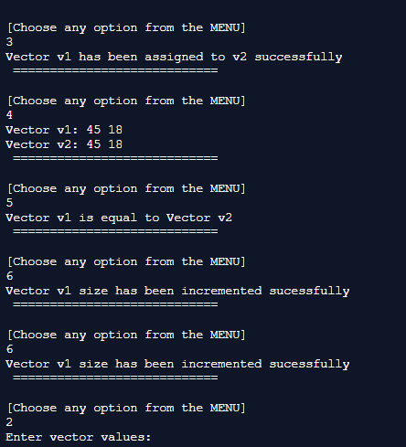

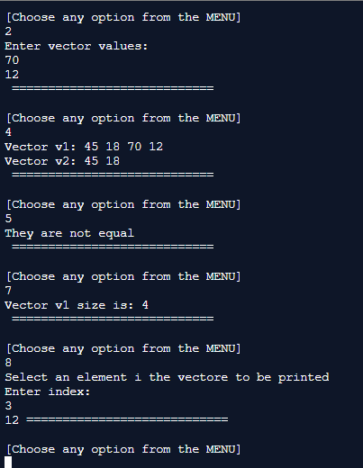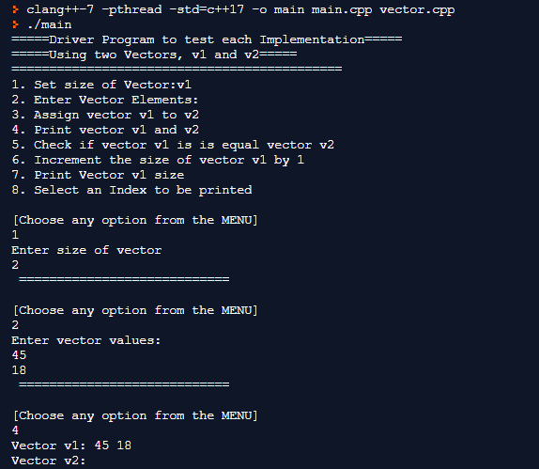

**Task-2:** Reconsider the Vector class declaration. Convert the implementation into a dynamic array form!

**vector.h**

#ifndef VECTOR_H

#define VECTOR_H

using namespace std;

class Vector{

public:

//default constructor

Vector();

//parameterized constructor

Vector(int);

//copy constructor

Vector(const Vector&);

//destructor

~Vector();

//Set function

void setSize(int);

//Get function

int getSize()const;

//overload “is equal” operator

bool operator==(const Vector&)const;

//overload “is not equal” operator

bool operator!=(const Vector&)const;

//overload “subscript” operator as a non-constant l-value

int& operator[](int);

//overload “subscript” operator as a constant r-value

int operator[](const int)const;

//overload “parenthesis” operator (passing index and value to be stored)

void operator()(int,int);

//overload “pre-increment” operator

Vector operator++();

//overload “post-increment” operator

Vector operator++(int);

//Created a customized push back function to test the driver program

void push(int);

//overload “stream insertion” operator

friend ostream& operator<<(ostream &,const Vector&);

//overload “stream extraction” operator

friend istream& operator>>(istream &,Vector&);

private:

int *list;

int size;

int current; //the number of elements currently in the vector

};

#endif

**vector.cpp**

#include <iostream>

#include <stdlib.h>

#include "vector.h"

using namespace std;

// Default constructor to initialise

// an initial capacity of 1 element and

// allocating storage using dynamic allocation

Vector::Vector(){

list = new int[1];

size = 1;

current = 0;

}

void Vector::push(int data)

{

// if the number of elements is equal to the capacity,

// that means we don't have space

// to accommodate more elements.

// We need to double the capacity

if (current == size) {

int* temp = new int[2 * size];

// copying old array elements to new array

for (int i = 0; i < size; i++) {

temp[i] = list[i];

}

// deleting previous array

delete[] list;

size *= 2;

list = temp;

}

// Inserting data

list[current] = data;

current++;

}

Vector::Vector(int c){

size = c;

}

//copy constructor

Vector::Vector(const Vector& vec){

size = vec.size;

}

//destructor

Vector::~Vector(){}

//set function

void Vector::setSize(int c){

size = c;

}

//get function

int Vector::getSize()const{

return size;

}

//overloaded "is equal to" operator

bool Vector::operator==(const Vector& vec)const{

for(int i = 0;i < size;i++)

if(list[i] != vec.list[i])

return false;

return true;

}

//overloaded "is not equal to" operator

bool Vector::operator!=(const Vector& vec)const{

return !(*this == vec);

}

//overloaded "subscript" operator

int& Vector::operator[](int index){

if(index < 0 || index > size - 1){

cout<<"Out of bounds!!!" << endl;

}

return list[index];

}

//overloaded "subscript" operator

int Vector::operator[](const int index)const{

if(index < 0 || index > size - 1){

cout<<"Out of bounds!!!" << endl;

}

return list[index];

}

//overloaded "parathesis" operator

void Vector::operator()(int index,int data){

if (index == size)

push(data);

else

list[index] = data;

}

//overloaded "post-increment" operator

Vector Vector::operator++(){

Vector t;

this->size++;

t.size = this->size;

return t;

}

//overloaded "pre-increment" operator

Vector Vector::operator++(int){

Vector t;

t.size = this->size;

this->size++;

return t;

}

//overload “stream insertion” operator

ostream& operator<<(ostream & display,const Vector& vec){

for(int i = 0;i < vec.size;i++){

if(i == vec.size - 1)

display<<vec.list[i];

else

display<<vec.list[i]<<" ";

}

return display;

}

//overload “stream extraction” operator

istream& operator>>(istream & input, Vector& vec){

cout<<"Enter Element to push: ";

int elem;

input>>elem;

vec.push(elem);

return input;

}

**main.cpp**

#include <iostream>

#include <stdlib.h>

#include "vector.h"

using namespace std;

void menu(){

cout << "=====Driver Program to test each Implementation=====" << endl;

cout << "=====Using two Vectors, v1 and v2=====" << endl;

cout << "============================================ " <<endl;

cout << "1. Set size of Vector:v1" << endl;

cout << "2. Enter Vector Elements: " << endl;

cout << "3. Assign vector v1 to v2" << endl;

cout << "4. Print vector v1 and v2" << endl;

cout << "5. Check if vector v1 is is equal vector v2" << endl;

cout << "6. Increment the size of vector v1 by 1" << endl;

cout << "7. Print Vector v1 size" << endl;

cout << "8. Select an Index to be printed" << endl;

}

int main() {

int x, num, option;

Vector v1,v2;

menu();

while(1){

cout<<endl<<"[Choose any option from the MENU]"<<endl; cin>>option;

switch(option){

case 1:

cout << "Enter size of vector" <<endl;

cin >> x;

v1.setSize(x);

cout << " ============================" <<endl;

break;

case 2:

cout << "Enter vector values: " << endl;

for (int i = 0; i < x; i++)

{

cin >> num;

v1.push(num);

}

cout << " ============================" <<endl;

break;

case 3:

v2 = v1;

cout << "Vector v1 has been assigned to v2 successfully"<<endl;

cout << " ============================" <<endl;

break;

case 4:

cout<<"Vector v1: " << v1 <<endl;

cout<<"Vector v2: " << v2 <<endl;

cout << " ============================" <<endl;

break;

case 5:

if (v1 == v2){

cout << "Vector v1 is equal to Vector v2" <<endl;

}

else

cout << "They are not equal" << endl;

cout << " ============================" <<endl;

break;

case 6:

v1++;

cout << "Vector v1 size has been incremented sucessfully" << endl;

cout << " ============================" <<endl;

break;

case 7:

cout << "Vector v1 size is: " << v1.getSize() << endl;

cout << " ============================" <<endl;

break;

case 8:

int a;

cout << "Select an element i the vectore to be printed" <<endl;

cout << "Enter index: " << endl;

cin >> a;

cout << v1[a];

cout << " ============================" <<endl;

break;

default:

cout<<"Option not available.. Please choose from the options above.."<<endl;

break;

}

}



